Year 12 Physics 2011 Electric Power

Unit Test

Year 12 Physics

2011

Electric Power

Unit Test

Name:

Mark: / 50

= %

Notes to Students:

* You must include **all** working to be awarded full marks for a question.
* Marks will be deducted for incorrect or absent units.

1. The Earth has a magnetic field. The angles of dip and declination vary from place to place. Draw the magnetic lines of force on the diagram below and show what is meant by angles of dip and declination.

[4]

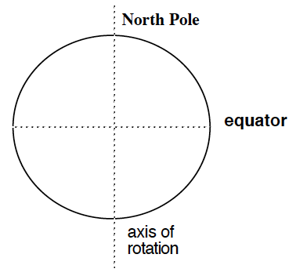

2. How does the ‘domain theory’ explain the properties of ferromagnetic materials?

[3]

3. The figure below shows a simple ac generator in operation. It is connected to a load R of resistance 7.00Ω and is turning at 20 Hz. It consists of a coil with 275 turns rotating in a uniform magnetic field B = 2.80 x 10-2 T.

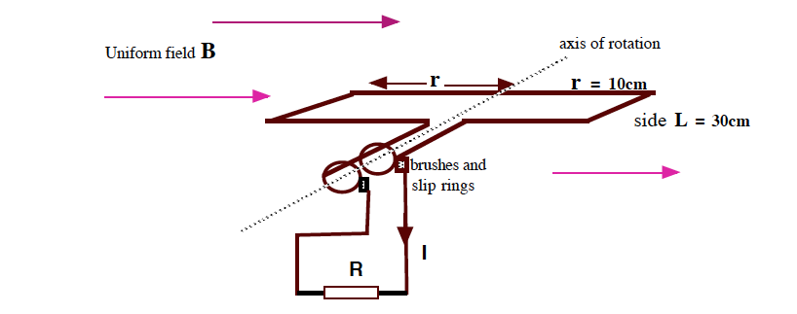

(a) State which way the coil is turning.

[1]

(b) What is the speed of the sides of the coil?

[3]

(c) What is the peak emf generated in the coil?

[3]

(d)What is the current through the resistor R?

[2]

(e)What is the torque required to turn the coil at this speed?

[3]

4. (i) What are ‘**eddy currents’** with respect to a d.c. motor?

(3)

(ii) How does a ‘**back emf’** form within a d.c. motor?

(4)

5.What are the magnitude and direction of the force on an electron entering the Earth's magnetic field at 1.75 x 108 ms- 1 directly downwards over the magnetic equator, where the flux density is

52.5 μT and horizontal.

[3]

6.A student is investigating the emf induced along a metal rod moving in the Earth’s magnetic field. The 3.00 m long rod is clamped, vertically upright, to the top of a train and is electrically insulated from the train. The train is moving at 72.0 km h-1 west in a region where the Earth’s magnetic field is horizontal and has magnitude 5.00 × 10-5 T.

(a) Calculate the value of the induced emf, showing your working. [3]

aerial



(b) Which part of the aerial will develop a positive charge? Circle the correct answer.

[1]

|  |  |  |
| --- | --- | --- |
| (i) top | (ii) bottom | (iii) there is not enough information supplied |

7. A transformer connected to a 240 V (rms) ac line is to supply 24.0 V (rms) to a portable electronic device. The total equivalent resistance of the portable electronic device is 9.00 Ω.

(a) What should be the ratio of the primary to the secondary turns of the transformer?

[2]

(b) What rms current must the secondary coil supply?

[2]

(c) What is the average power delivered to the load?

[3]

(d) If the transformer is 73% efficient what is the power and current in the primary circuit?

[3]

8. The distribution circuit of a residential power line is operated at 2000 V rms. This voltage must then be reduced to 240 V rms for use within houses. Why is it necessary to have such a high voltage on the distribution circuit of the power line?

[3]

9.A physics teacher set up the equipment shown below.

One tube was made of plastic and the other of aluminium. The teacher dropped a strong rare earth permanent magnet down each tube.

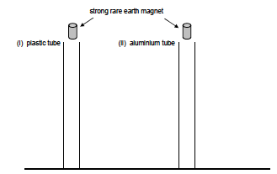

The magnet falling through the plastic tube travelled much faster than the magnet falling through the aluminium tube.

Explain, indicating clearly the physics principles involved.

[4]

End of test